PRE-EVENT INFO FOR COMPETITORS
Welcome from Orienteering Bay of Plenty! We are really looking forward to seeing you at the Great Forest Rogaine. The following information is provided to help you understand the rules, safety, and practical matters ahead of arriving at the event. Please read and if you have any questions, contact the organiser (details at bottom of page).
RULES AND SAFETY
All competitors must read these rules prior to the event, and bring your signed waiver form (at bottom of this document) to registration on Saturday.
Generally we find most competitors to have a great attitude and come with a positive spirit of competition for the GFR. However we do need to emphasize a few important rules and we ask that everyone reads these carefully, and then abides by them during the event.
In the rare instance of someone breaking the rules we have a range of penalties available to us, depending on the severity of the breach. In the event of blatant cheating and major infringements disqualification will occur. These rules are in place for the safety of individuals and other forest uses. Breaching of these rules may impact our access to the forest and place future events at risk.
SAFETY
- When planning your course and crossing areas think carefully about the team’s abilities, the terrain and take appropriate precautions.
- Treat every road including forest roads as open to traffic and abide by normal traffic rules and etiquette. Be particularly careful on Hill Road where the mountain bike shuttle operates, as well as Long Mile which can often be busy with cars.
- In the event of getting lost, the safety bearing is north and west to the main roads.
- For 6hr Foot rogaine competitors undertaking off track travel in the native forest in the North East part of the map, we recommend a safety bearing that takes you to the main track bisecting the area (Tuhoto Ariki). or West to Hill Road. DO NOT ATTEMPT A SAFETY BEARING EAST TO BLUE LAKE AS VERY STEEP TERRAIN AND CLIFFS EXIST IN THIS AREA (marked on the map)!
- Please notify organizers of any health issues before you start.
- The organizers contact mobile phone number is on the map, as well as the phone number for the First Response team in the event of injury or medical event requiring evacuation. Cell phone reception can be found in many parts of the forest, but not everywhere.
- In the event of a serious injury or medical event, offer first aid to the person, phone for help and/or send one of the team for help (if more than two people in the team). If only two people, stay with the injured person and using your whistle, blow 6 blasts on the whistle to alert for help. These 6 blasts should be repeated every minute or two until someone hears you and help arrives.
- Our expectation is that teams should render assistance for any other team in distress if requested.

COMPULSORY GEAR
The compulsory gear list has been created with consideration to the safety of competitors, and the time of the year when cold/wet conditions could occur. All competitors and teams are required to carry:
- Torch/headlamp with sufficient batteries (each individual)
- Whistle (each individual)
- ​Waterpoof jacket (each individual)
- Hat and gloves (each individual)
- Spare thermal top - wool or polypro (each individual)
- Thermal long johns or tights (6hr foot only - each individual)
- Race food and drink (each individual)
- Backpack to carry above (each individual)
- Mobile phone sealed in a waterproof bag (per team)
- Compass (per team)
- Space blanket and first aid kit (6hr only - per team)
The organisers will be doing spot checks on gear, so please ensure you bring everything on this list.
COMPETITION RULES
- Stay Together - All team members must stay within 20-30 metres of all their other team members at all times. All team members must visit the control site - IT IS NOT ACCEPTABLE FOR ONE TEAM MEMBER TO VISIT A CONTROL SITE WITHOUT THE REST OF THEIR TEAM.
- Comply with all instructions - Competitors must comply with any safety instructions given out at registration and by the officials at the event.
- Must carry the compulsory equipment - no exceptions.
- No External Assistance - Competitors must not receive any external assistance. (this includes the MTB shuttle bus)
- Please be aware that all tracks and forestry roads are open to the public during the event. There will be other forest uses and vehicles on the forestry roads especially along the bike shuttle bus route. Please take care on all forestry and public roads and observe the usual road rules.
- Be aware that some tracks are dual use (foot and MTB) so care is needed to avoid collisions.
- Please show respect to other forest uses throughout the event, and take special care around families and young children.
- Competitors may carry a wearable GPS for the purposes of tracking their activity so it may be downloaded post event (for sites such as Strava etc). However these are NOT allowed to be used for navigation purposes during the event. GPS devices with mapping software installed may not be used at all (eg handheld GPS's or smart phones with mapping software installed).
- Note for the MTB categories, there are some controls that competitors may choose to get which are off track, up to approx 100 metres or so. Competitors may leave their bike and go on foot to these off track controls.
- This year the 6hr Foot course has a number of control sites which are well off track in a more remote part of the forest, and which present a higher level of navigational challenge than previous GFR rogaines. Competitors who are not confident navigating in off track terrain, some of which is in dense bush, should consider selecting control sites which are within their navigational ability. There are no tracks or markers to these off track control sites, so competitors attempting to visit these control sites MUST know how to use a map and compass.
- Off track terrain is generalized as light green on the map, however can vary from open clean forest with minimal low foliage (fast travel), through to dense bush with supplejack and windfall (very slow travel). Care should also be taken in streams which can be slippery and rocky, and the occasional steep bank or cliff. Whilst caution should be exercised, we expect competent navigators to enjoy the off track control options. Some parts of the map indicating dark green or dark green stripe signify travel that is very slow and difficult. Note we have only mapped dark green in some areas only and these conditions may be discovered in the light green mapped areas as well.
- Not all illegal tracks have been mapped, so do not be surprised if you come across illegal tracks not on the map. As above, these can be used for foot competitors, but not MTB competitors.

POINTS
- Controls range from 30 points to 100 points in value. The points value of the control is based on the control number used, E.g. control number 32 is worth 30 points, control number 87 is worth 80 points and so on.
- The penalty for being late is 50 points per minute late. Anyone over 30 mins late will lose all their points.

TRACK AND OFF TRACK TRAVEL - WHAT IS ALLOWED AND NOT ALLOWED
The maps for the foot competitors and MTB competitors use different colour coding to signify allowable and non allowable tracks. It is critical competitors understand the following information:
FOOT COMPETITORS
- Can use walking and dual use trails (marked in black on the map)
- May leave the tracks and travel cross country, although it can be very dense in some parts of the forest.
- May not travel through Out Of Bounds (OOB) areas (marked with purple hatching or Olive green on the map)
- Must NOT use MTB trails (marked in red on the map). However they can cross (with care), but must not run along any mountain bike trails.
- Must not use other misc tracks; those under construction, horse trails, spray lines etc (marked in red, or which have red X marks on the map)
- Some uphill dual use trails are one way only and can not be descended. These trails have a red one way arrow signifying allowable direction.
- May use "illegal" Mountain bike tracks (marked in purple on the map), but must be careful and be prepared to give way to "illegal" recreational riders
MTB COMPETITORS
- May ride MTB trails (marked with black and orange dashes on the map)
- May ride dual use trails and roads (marked in black on the map)
- Must not ride on any walking only tracks (marked in red on the map)
- Must not ride "illegal" mountain bike tracks (marked in red on the map)
- Must not ride other misc tracks; those under construction, horse trails, spray lines etc (marked in red on the map, or which have purple X marks)
- May leave the tracks and travel cross country anywhere on the map (with bike). May travel short distances without bikes to off track control sites.
- Must ride one directional MTB tracks in the direction of the arrows on the map, if there are no arrows on the map the track can be ridden in either direction.
- If competitors overshoot on a one directional tracks and need to go backwards a short distance on a track they must dismount and push their bike along the side of the track. This is for short distances only, maximum 50 metres. ​
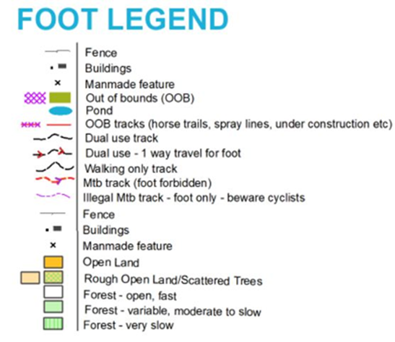 | 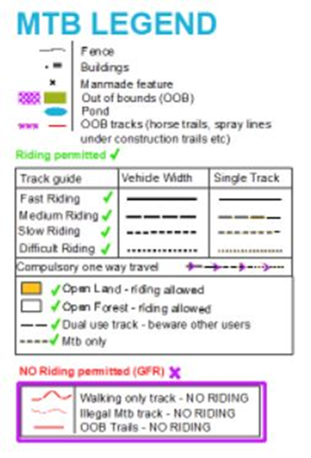

OTHER PRACTICAL INFORMATION
PARKING
We are not able to park everyone in the school grounds.
- 6 hour Foot and MTB competitors can park on the concrete areas in the school grounds as directed by parking marshalls.
- 3 hour Foot and MTB competitors should park in the Froude Street car parking area. It is only a 200-300m walk to the school grounds from there. Please keep to the paths on the southern side of Sala Street and watch for traffic turning into or out of side roads.
Both parking areas will be clearly signposted from Sala Street, as well as the route to the start from the Froude Street car park. Please follow the instructions of the parking

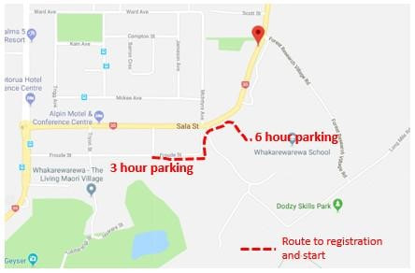

SPORT IDENT TIMING SYSTEM
The event will be timed and scored using electronic SPORTident cards (dibbers). Every team will receive one dibber at registration to use for the event. A team member will need to insert the dibber into the control box at every control to prove that the team has visited that control. It is the responsibility of the team to carry and look after their dibber card so that it can be handed in at the finish as evidence of the controls that they have visited. Lost dibbers will incur a $130 cost for replacement, paid to OBOP.
REGISTRATION INFORMATION
- Please advise us early on the day of any changes to your team details, particularly your teams name, category and team members’ names.
- For those pre-entered and paid please visit registration to confirm your details and collect your sport ident dibber, control descriptions and (optional) map bags.
- If you have registered but not paid please visit registration to do so.
- For those entering on the day please visit registration to provide your details and payment. The cost to enter on the day is an additional $15 per person (except under 12). Enter on the day entries will be first come first served, and in the event that we run out of maps, then entries may be declined.
OUTSTANDING PAYMENTS
We will send out emails regarding outstanding payments.
If you have receive this email please pay and action as appropriate as soon as possible. If you don't pay in advance you will need to bring cash on the day to register and receive your map.
START INFORMATION AND TIMETABLE
- There will be a briefing prior to map release for each event and then competitors will be given their maps. It is recommended that you have all your gear with you and be ready to race as you will want as much planning time as possible. You will be able to visit the toilet during this time.
- Every competitor will receive a copy of the map which has been printed on waterproof paper.
- Please remember to bring permanent markers, highlighters, pens etc to assist planning your course and marking up your maps. Feel free to ask questions during this planning time. There will be some limited assistance available to those new to rogaining who want some tips and advice.
- There will be a final briefing and chance for final questions and then the event will start. Start Time will be shown on a large clock at the event centre - competitors should synchronize their watches with the official clock. Finish time for the 6hr will be 6hrs after the start. The 3hr will start 3hrs into the 6hr event, so will share the same finish time.
Timetable
8-9 am 6 Hour Registration
9am Briefing and maps released (6 hour)
10-4 pm 6 Hour event in progress
11-12 pm 3 hour Registration
12 pm Briefing and maps released (3 hour)
1-4 pm 3 hour event in progress
4.15 pm Pizza
ASAP Prizegiving
PIZZAS
We have allowed 1/2 a pizza for every competitor and we ask that you are considerate and respect this when getting pizza after the event. There are a number of vegetarian and gluten free pizzas for those that require them. We would greatly appreciate it if people can completely empty, flatten and stack their pizza boxes when done. Even better – take them home!
PRIZES
Winners of each category will receive Vouchers from Zippys cafe, who has been a huge supporter for OBOP over the years and who we are delighted to support this year post COVID-19.
We have 5 x $50 vouchers to local restaurants to give away as a spot prize to random competitors, and a grand spot prize of $250 (voucher) from a local outdoor retailer. People must be present at prize giving to receive prizes.
We encourage competitors and their family and friends to support these and other local businesses who have been heavily impacted by COVID-19. Zippys and other local businesses have been active supporters of OBOP events over the years and we look forward to repaying their support at this time.
Looking forward to a great day!
The Great Forest Rogaine Organizing Team and OBOP.
CONTACTS
Event organizer – Erin Swanson, erinroberts08@gmail.com, Ph 021 386 977
Event Planner and Controller – Peter Swanson, peteswanson64@gmail.com, ph 027 302 4863

WAIVER FORM – GREAT FOREST ROGAINE, JULY 25, 2020
I declare that:
- I am in an appropriate physical condition to participate in the Event, given the known parameters of the Event (such as the length, time, physical demands and environmental context).
- I have taken medical advice on any pre-existing medical conditions, and confirm that it is medically safe for me to participate in the Event.
- I acknowledge that there are risks involved in the Event. I fully realise the dangers of participating in the Event, and fully assume the risks associated with my participation and my wellbeing and safety during and after the Event, and recognise that my own actions will determine my own safety. I understand and acknowledge that the Event organisers (including all officials and event volunteers) have taken reasonable precautions around safety, however provide no warranties, regarding my wellbeing and safety.
- I understand and agree that situations may arise during the Event, which may be beyond the immediate control of the Event organisers (including all ofﬁcials and event volunteers).
- I will participate in the Event, in a manner that does not endanger either myself or others.
- I agree that to the extent permissible by law, the Event organisers (including all officials and event volunteers), the sponsors and other parties associated with the Event, have no liability to me whatsoever for any direct or indirect loss, (including, but not limited to injury or death) sustained by me during or in any way related to my participation in the Event.
- I agree to comply with the rules, and regulations pertaining to the Event.
- I agree to follow all reasonable safety instructions provided to me by the Event organisers, (including all officials and event volunteers) before, during and after the Event.
- I agree that I have read, understand, and agree to the rules and safety instructions provided by the organisers for this event.

Name:…………………………………………………………….. Team Name:………………………………………………………………..

Signed:…………………………………………………………………………………………………………
(Signature of caregiver if entrant is aged under 18)

Date:……………………………………………………………………………………………………………
Please hand in completed and signed Waiver form to registration on Saturday.

